Pokhara University

Level: Bachelor | Semester – Spring | Year : 2006
Programme: BE |  | Full Marks: 100
Course: Signal System and Processing |  | Time : 3hrs.

Candidates are required to give their answers in their own words as far as practicable.
The figures in the margin indicate full marks.

Attempt all the questions.

 | - Determine the Fourier Transform of the rectangular pulse signal defined as 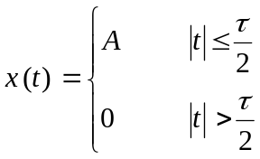  - Find the output y(n) for an LTI system having impulse response h(n) = {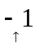, 0, 3, 1} and input signal x(n) = {,3, 2, -2}. | 8  7
 | - Determine the orders of the Low pass Butterworth filter that has a-3 dB bandwidth of 500 Hz and an attenuation of 40 dB at 1000 Hz.  - Transform the single Pole Low pass Butterworth filter with system function H (s) = 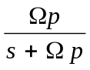 into a band pass filter with upper and lower band edge frequencies 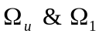 respectively. | 8  7
 | - Consider a system described by the difference equation y(n) = y ( n- 1) – y ( n- 2) + 0.5 x(n) + 0.5 x (n-1)  Find the response of this system to the input x (n) = (0.5)^{n} u(n) with initial conditions y ( -1) = 0.75 and y (-2) = 0.25.  - Find Z-transform of  - x[n] = nu [ n – 1]  - x[n] = -a^{n} u[-n – 1] | 8  7
 | - Obtain the direct term- I realization for the system described by the following difference equation y(n) = 0.5 y (n – 1) – 0.25 y ( n – 2) + x (n) + 0.4 x (n – 1) Also represent the same system in direct form II structure and compare the structures.  - Define FFT and compare the computational complexicity of DFT with FFT using any approaches of FFT. | 8  7
 | - Explain the mapping procedure from S-plane to Z-plane using impulse invariance method. How this mapping is different from that of bilinear transformation method?  - Consider an analog signal  - What is the Nyquist rate for this signal?  - Assume that we sample this signal; using sampling rate Fs = 5000 samples/sec. What is the discrete- time signal obtained after sampling?  - What is the analog signal we can reconstruct from the samples if we use ideal interpolation? | 8  7
 | - What is Gibb’s phenomena? How could you minimize the effect of Gibbs phenomena? Explain.  - Write down the procedure to design the FIR filter using the frequency sampling method. | 8  7
 | Write short notes on:  - Truncation and Round-off errors  - Spectral transformation (low pass to band pass) | 5×2

